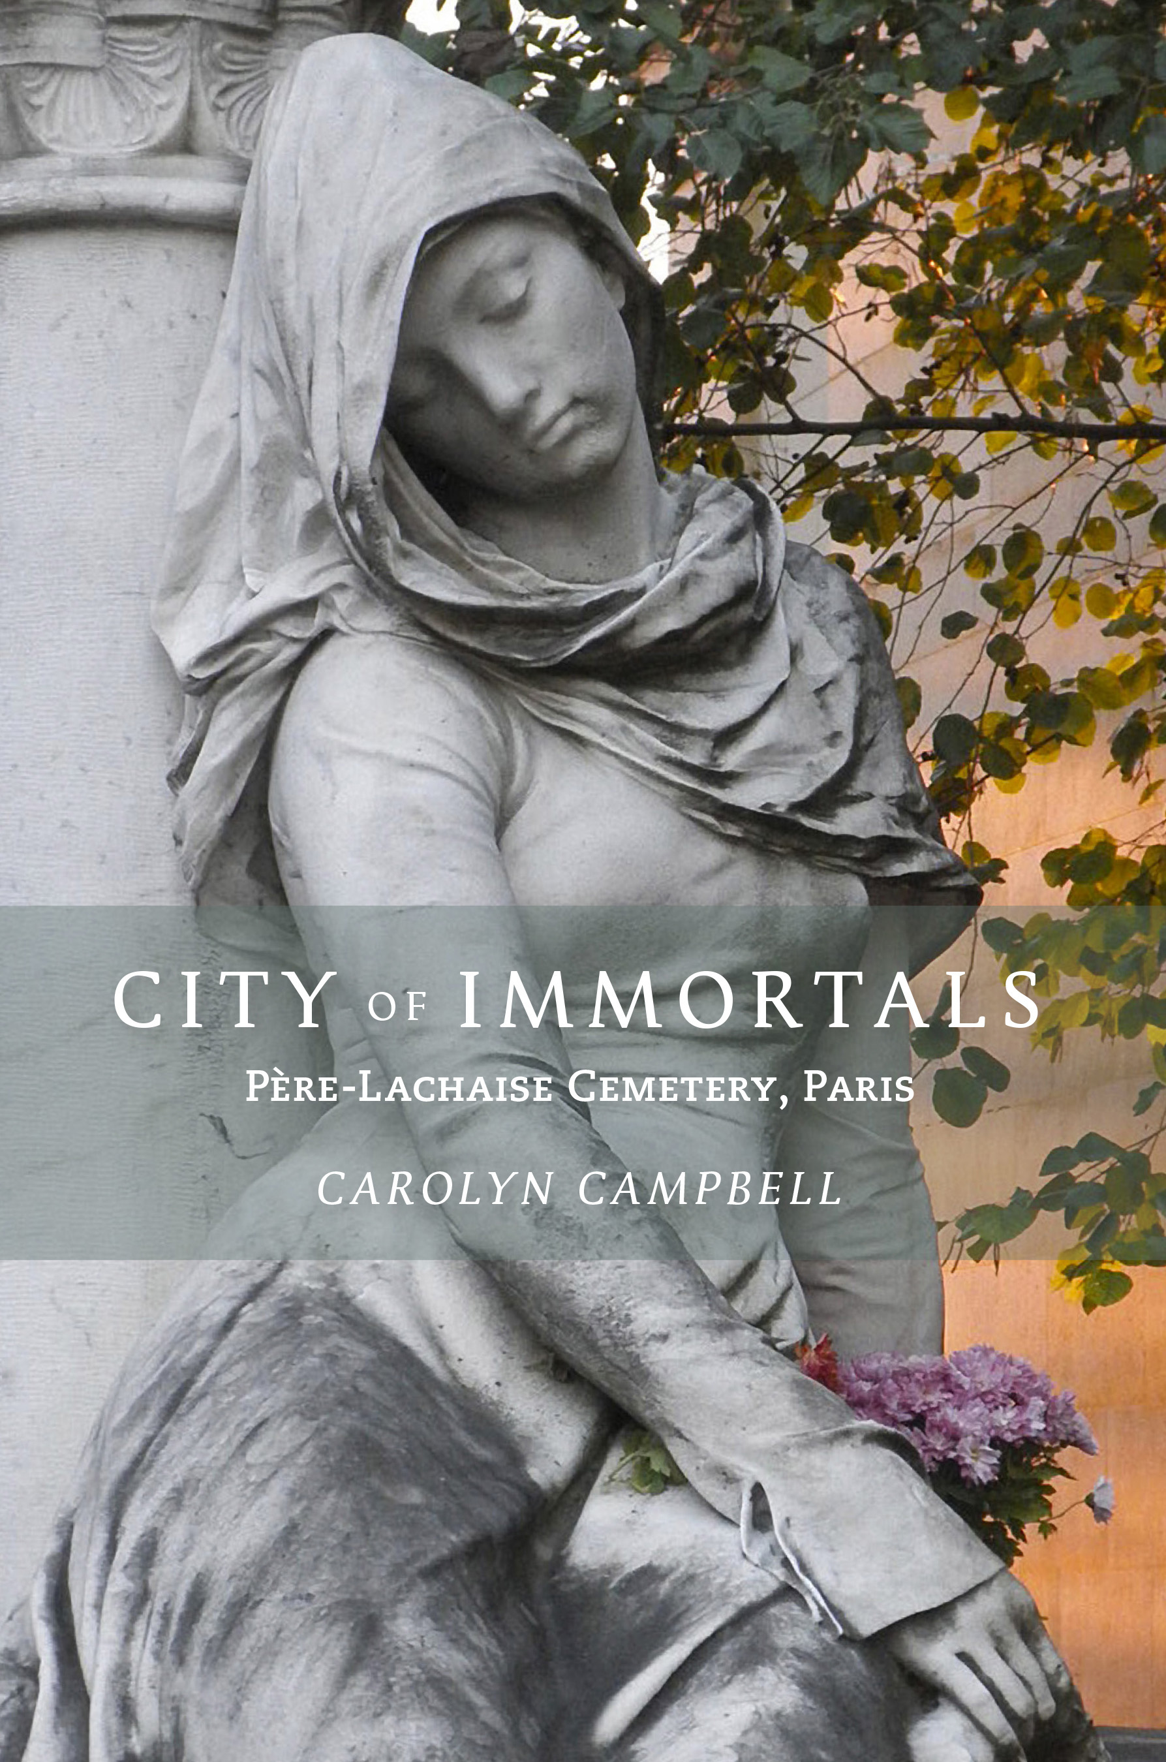
City of Immortals:
Père-Lachaise Cemetery, Paris: New Book Celebrates the Rich and Beautiful History of the World’s Most Famous Cemetery
New, Unpublished Material and Comprehensive Map Provide an Insider’s Guide to the Legendary Parisian Necropolis and Tourist Destination

“I seldom go out, but when I feel myself flagging, I go out and cheer myself up in Père Lachaise…while seeking out the dead I see nothing but the living.”
– Honoré de Balzac, Père-Lachaise resident

LOS ANGELES (June 24, 2019) – In October 2019, Goff Books will release City of Immortals: Père-Lachaise Cemetery, Paris, the first all-inclusive look at the history of the world-renowned cemetery from its 1804 establishment by Napoleonic decree to the present. Featuring new unpublished material, the book contains over 100 original color photographs, historical lithographs dating from the early 19th century, and a comprehensive illustrated map of the legendary necropolis that draws millions of tourists to the City of Light each year.

“If the world ‘necropolis’ means ‘city of the dead,’ then Père-Lachaise is indeed the City of Immortals. The deceased found within its walls do not rest, but instead live forever,” said author Carolyn Campbell, whose voluminous research and extensive photography of the cemetery over the last three decades gave birth to this new book. “It gives me great pleasure to share the beauty and mystery of this place with others. The legacy of the cultural icons, rebels, intellectuals, innovators, and rule-breakers buried there reminds me of the importance of taking risks and giving voice to whatever creative contribution you leave behind.”

Arguably the most famous and most visited cemetery in the world, Père-Lachaise is a 107-acre labyrinth housing an eternal “salon” of luminaries from the worlds of art, design, literature, the performing arts and more. Boasting the final resting places of more celebrated artists and thinkers than any other location in the world, the cemetery has, in the last century, become a pilgrimage site for visitors from all over the world to pay their respects. It is also a magnificent open-air museum of sculpture and architecture, representing the first revolutionary design in memorial parks and the fourth most popular destination for the 65 million tourists who visit Paris each year (behind the Eiffel Tower, Notre Dame, and the Arc de Triomphe).

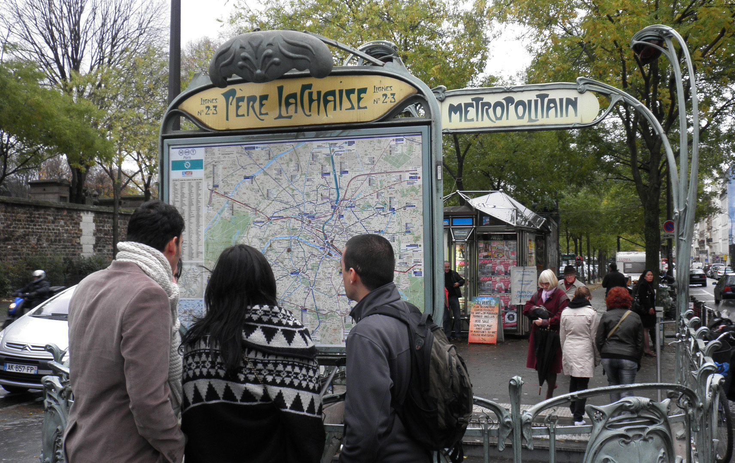

Just in time for Halloween, All Souls Day, Dia de los Muertos, and holiday gift shopping, Campbell presents this first-person account of her more than thirty years visiting, studying, and documenting Père-Lachaise. Campbell’s evocative images, complemented by those of renowned U.K.-based landscape photographer Joe Cornish, celebrate the novelty and eccentricity of the site through its engrossing history, cultural iconography, and genre-defining architecture and design. It’s a volume sure to delight Fracophiles, tourists, and armchair travelers, while also enriching the experience of taphophiles (cemetery lovers) and aficionados of art and architecture.

City of Immortals also boasts several intimate “conversations” with some of the cemetery’s high-profile residents and three guided tours, alongside the illustrated pull-out map, each acknowledging the eye-popping expanse of Père-Lachaise. In the book, tours, and map, Campbell focuses on the grave sites of eighty-four architects, artists, writers, musicians, dancers, filmmakers and actors, including: Oscar Wilde, Jim Morrison, Gertrude Stein, Frédéric Chopin, Georges Bizet, Edith Piaf, Maria Callas, Isadora Duncan, Eugène Delacroix, Amedeo Modigliani, Sarah Bernhardt, Simone Signoret, Colette, Marcel Proust, and many more.

Campbell’s fascination with Père-Lachaise began in the early 1980s while working at the Corcoran Gallery of Art in Washington, D.C. Armed with a bargain flight to Paris and a mission to find Oscar Wilde’s tomb (which she did not find on that first visit), the pilgrimage started a more than three-decade fascination with telling the eternal stories of those responsible for and interred at Père-Lachaise.

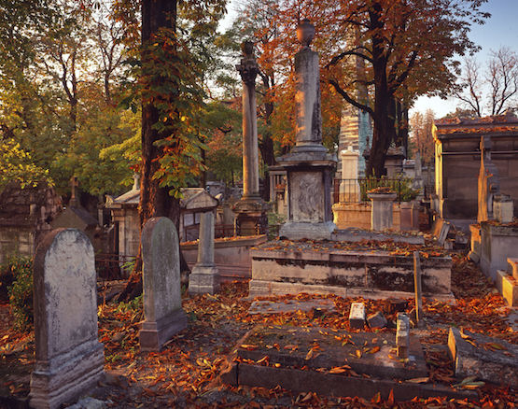

Marking the 215th anniversary of the cemetery, in May of this year, Campbell also launched the City of Immortals GPS Tour App on both Apple and Google devices. With the goal of both simplifying and broadening the Père-Lachaise experience, the app provides visitation and transportation details, the general history of the cemetery, and background on the designs of the 19th-century funerary art and architecture to be found there. In addition, it features images, biographies, and navigation details to the grave sites of the same 84 cultural icons featured in the book.

To pre-order City of Immortals: The Père-Lachaise Cemetery, please visit goffbooks.com. To learn more about Campbell’s work, visit cityofimmortals.com. For images or a review PDF, please e-mail media contact Katie Dunham at katie@katiedunham.net.

###

About Carolyn Campbell
Writer and photographer Carolyn Campbell was born in Washington, D.C., has lived in Paris, and is now a resident of Los Angeles. Her fascination with Père-Lachaise was kindled on a first visit to Paris in 1981. With the support and encouragement of her mentor, the late New York Times art critic John Russell, she embarked on her research and photo documentation of the cemetery. A summa cum laude graduate of the Maryland Institute College of Art, she has been working as an arts and communications specialist for over 30 years. She has held executive positions with the Corcoran Gallery of Art, the American Film Institute, and the UCLA School of the Arts and Architecture, where she was also editor of the UCLA Arts for fourteen years.

About Goff Books
Goff Books publishes aesthetically vibrant books that provoke the imagination and rouse the creative spirit. Our hope is to inspire individuals and communities by illuminating and illustrating a world filled with beauty and potential for unique and awesome opportunities. From breathtaking photography to lifestyle topics, from chic fashion to world-class art and urgent social issues, Goff Books features stimulating insight into the worlds of pop culture and visual literature. The artistic foundation of our projects drives our inventive production process—further presenting vivid imagery that accentuates original content and creating the ultimate reader experience.

